Okta services are on top of AWS

30K USERS, 2AD Agents

Within AD-Forests-domains-OU

Each AD has ad domain controller

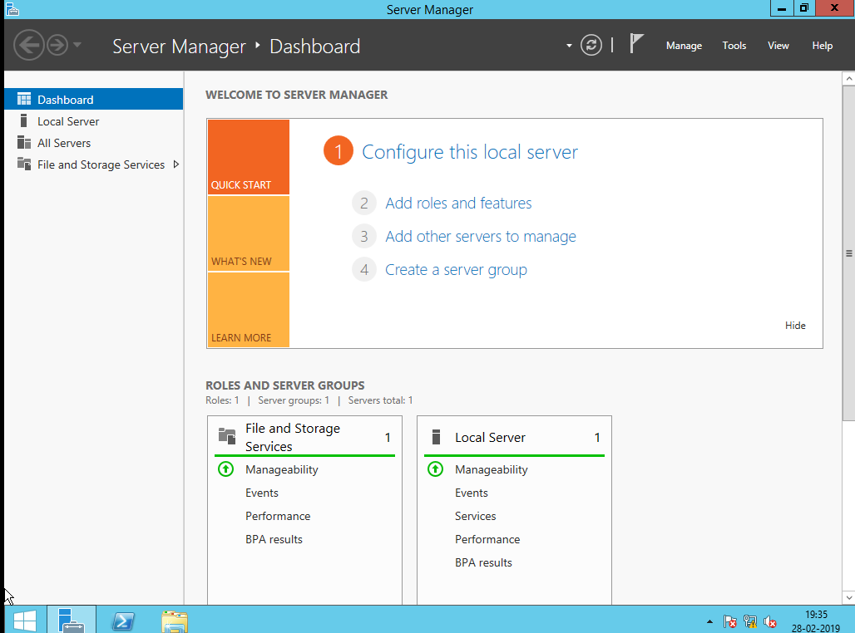

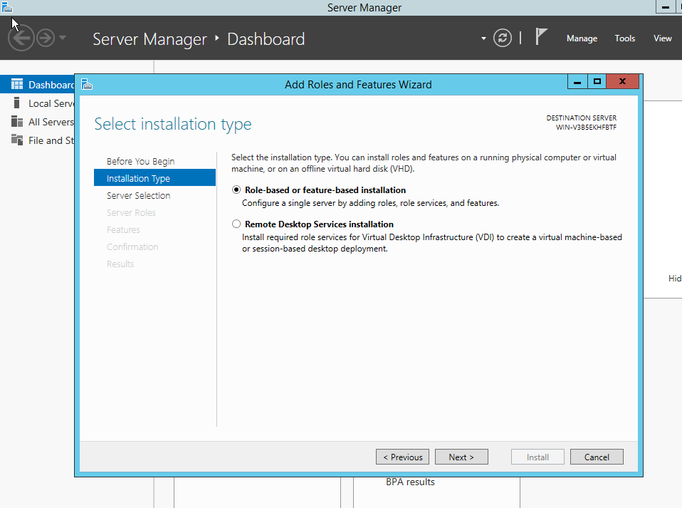

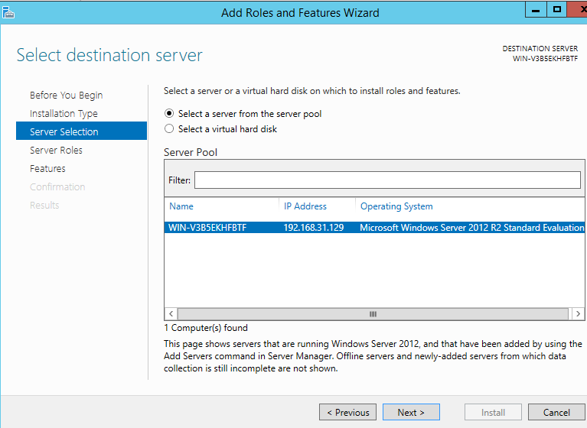

AD domain services select

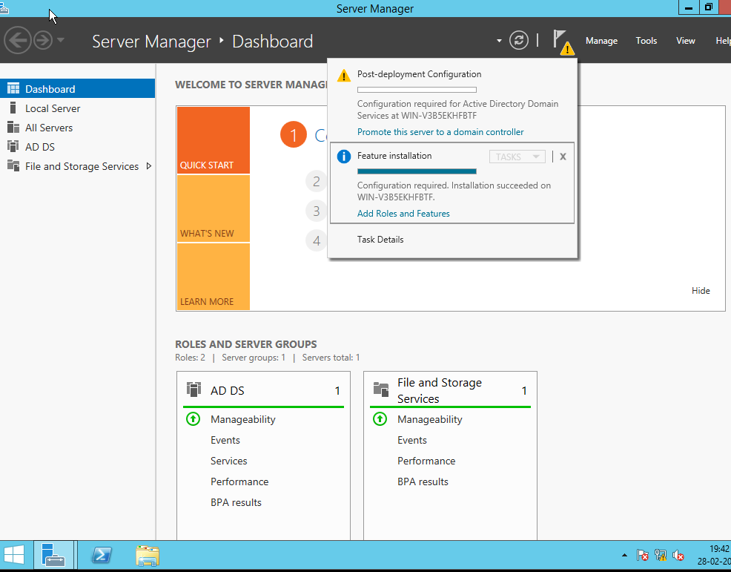

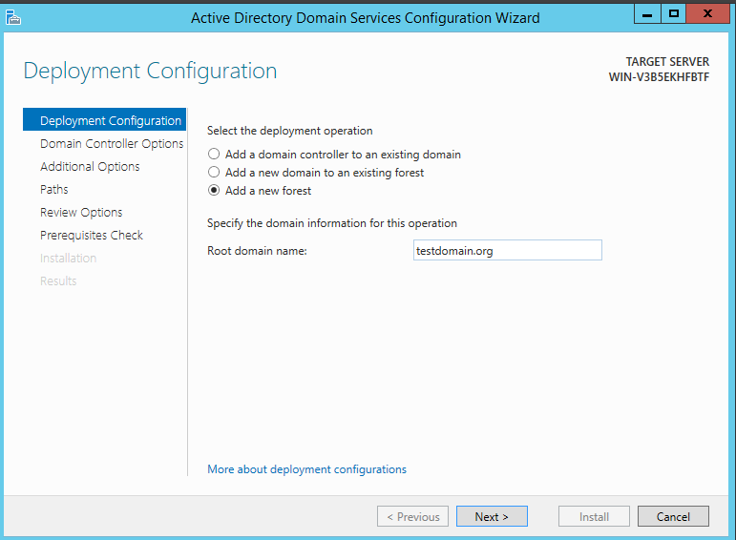









[Trial.user@testdomain.org](mailto:Trial.user@testdomain.org)

Groups- domain, global, local



AD agent and Okta port 636